

Mentoring, Training & Placements Department
Daily Report 30-03-2026
Description |  | Total to be received | Received till Date | Received Date | To be received

II | Staff Attendance
S.No | Dept. | Category | On Rolls | Absent | DQI | DQI Performance | Overall DQI | Overall Performance
1 | MTP |  | 8 | 1

 | III. Students’ Attendance:
IV | MTP:  SAMUEL  - Amazon Non-Tech Internship hiring - 4 students from 3rd year are selected by Amazon for internship role with a stipend of 70 K monthly.  - Mech -2, Civil & AME-1 each  - INFOSYS Hackwithinfy contest round-1 was organized on 28th March. Approx 1000 students out of 1450 registered students have given confirmation about their participation.  - DBS Internship hiring - DBS team has organized an online test on 27th March during 5pm to 8 PM. Our 3rd year students from CSE, IT, AIML have attended the same. Results are awaited.  - JPMC Summer Internship hiring - further to Round-1 Coding assesment, 420 students have received Hirevue Test link and students have finished the same on 28th and 29th March.  - Kumaran Systems hiring - On-campus drive is confirmed on 31st March. Arrangements made and informed all the students.  POONAM  - JARO Education: 3 students from Batch 2026 got selected for JARO Education for Graduate Trainee-Role, with CTC: 10.76 LPA  - 22071A02C2 Thalari Sathwik EEE  - 22071A0297 Sai Meghana Kunjeti EEE  - 22071A0449 Siddhika Rudraraju ECE  - Alladi Cloud Solutions Pvt Ltd: 6 students will attend the on-site final round with MD tomorrow (31-3-26) at 10:30 AM.  - STUAM- 11 students from B.Tech EIE 2026 batch profiles shared with HR for hiring Techno Marketing role, offering CTC. 5 LPA, Location- Hyderabad.  - An orientation and training session was conducted by Dr. K V M Achuta Ramaiah on 28th March’26, 2 to 4 PM, in view of JPMC Hirevue (video interview) round (2028 batch). Over 300 students attended this session.  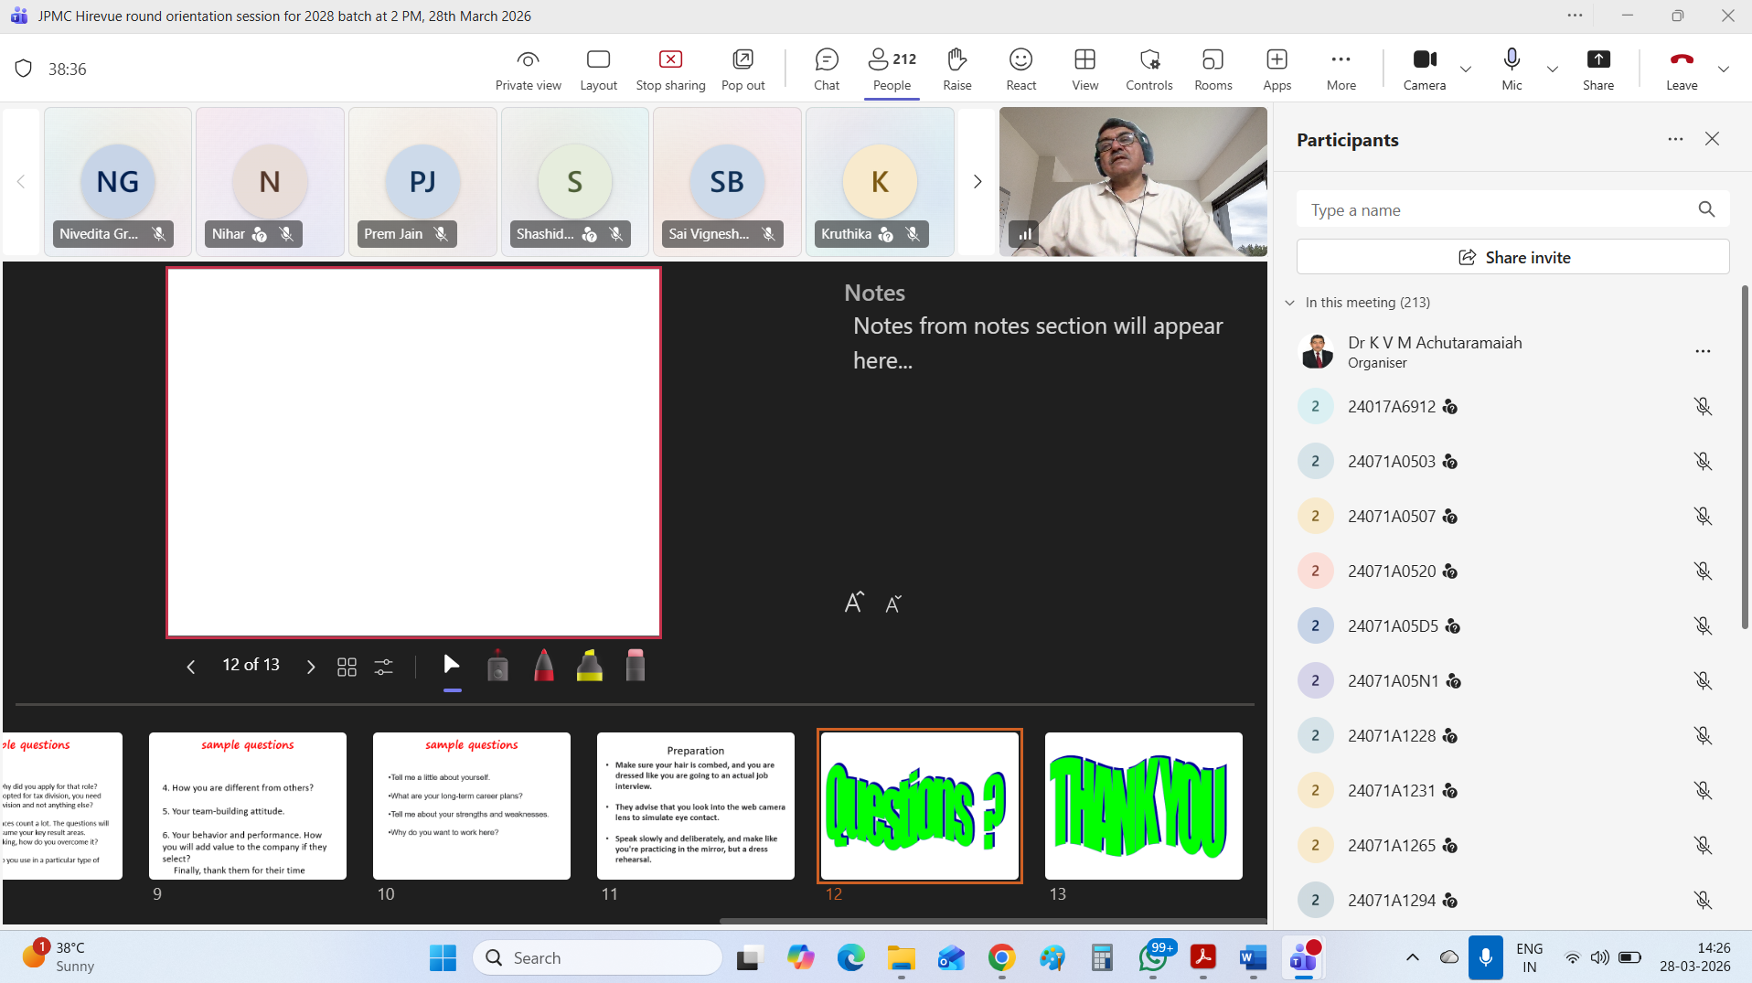 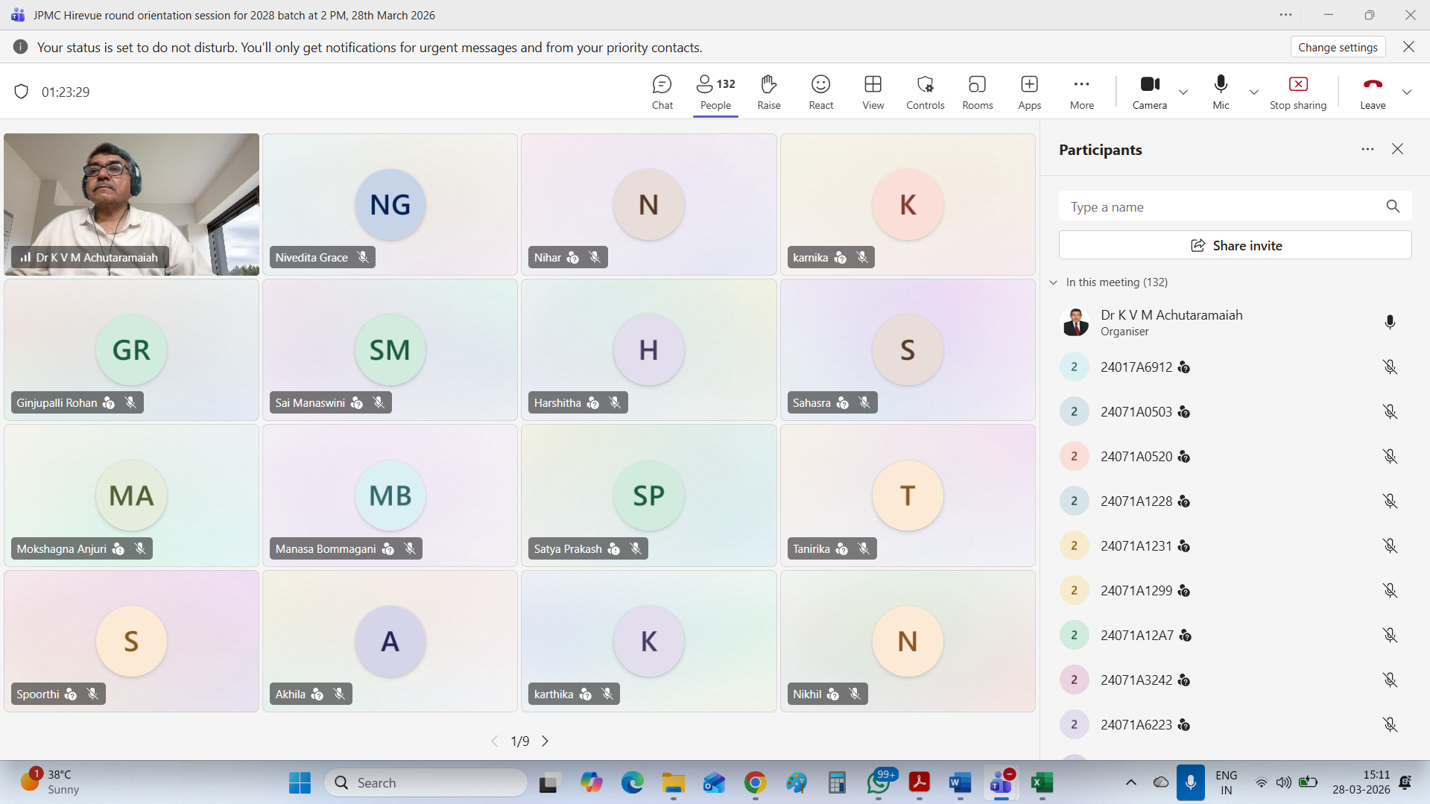  V HOD-CSE (CSDS&AIDS):  VI HOD-IT:  VII HOD-ECE:  2025 2026 Batch Plis open Summary:  CSE CSBS AIML IOT DS CyS AIDS IT ECE EEE EIE ME CE AE M.TECH TOTAL  359 65 276 85 187 63 65 249 207 83 92 57 62 19 18 1887  2025
VIII Classwork Adjustment / Lectures Interchanged:
S. No. | Dept | Subject | Adjusted from | Adjusted to

IX. Participation by Staff/Students:
S.No | Name | Event | Status (delegate /paper)resent, speaker) | Date and  Duration

X | Particulars of Library Services or Transactions: | No.s

For Head of the Department.

